Sky Destroyers

Team members: Mihai Dumitru

Similar products & Relevant Links(>=3)

**Tiny Combat Arena**

**https://store.steampowered.com/app/1347550/Tiny_Combat_Arena/**

**Relevant Features**

-Semi-realistic flight models/aerodynamics

-Bullet ballistics and missiles ai

-PS1 era style graphics

**Warthunder**

**https://warthunder.com**

**Relevant Features**

-semi-realistic/realistic flight models and aerodynamics

-variety of large and small maps based on aircraft capabilities

-a large aircraft variety of different kinds from different eras and loadout customisation

**Ace Combat 3**

**https://acecombat.fandom.com/wiki/Ace_Combat_3:_Electrosphere**

**Relevant Features**

-arcade style flight models and aerodynamics

-a story campaign with multiple missions

-a variety of modern aircraft and loadouts

-------------------------------------------------------------------------------------

Main Features

-semi-realistic flight models and aerodynamics

-a few different maps

-a few different aircraft

-2 points of view (cockpit view, 3rd person view)

-some different loadouts for each aircraft

-a rudimentary ai for aircraft and ground units

-basic time of day and weather effects

User Journey



Moodboard

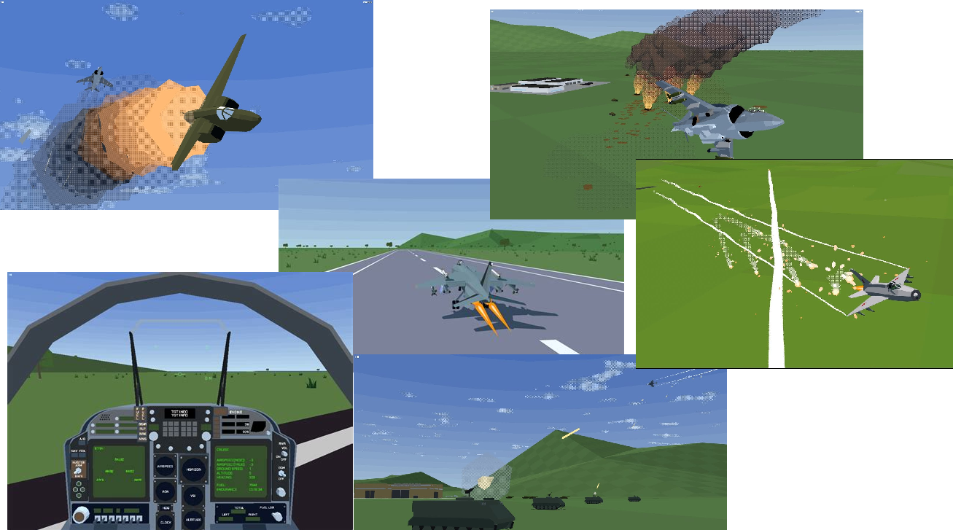

Technologies, Libraries, Assets (>=5)

Blender for modeling game objects.

Unity engine for the game development.